# A team of Czech scientists together with other "geopartners" from all over the world won a prestigious UNESCO project

**This year, only five projects from around the world were selected for support from the UNESCO International Geoscience Program. In a great competition, a joint project submitted by a team of Czech scientists and five geoparks from Tanzania, Nicaragua, Peru, Philippines and Czech Republic obtained one the highest scores in evaluation.**

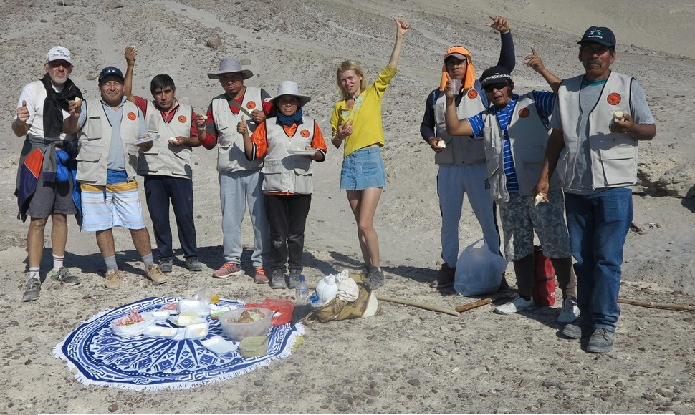

The concept of geoparks originated bottom-up, as an expression of the desire to share and at the same time protect the valuable natural heritage of the Earth. "*However, since 2015, the geoparks movement has gained the opportunity to use the official status of UNESCO global geoparks. Not only is this a prestigious issue, but today geoparks from all over the world can work better together to preserve and promote geological and other natural and cultural assets,* "says Martina Pásková, a member of the UNESCO Global Geoparks Council and Associate Professor at the University of Hradec Králové, the Czech Republic.

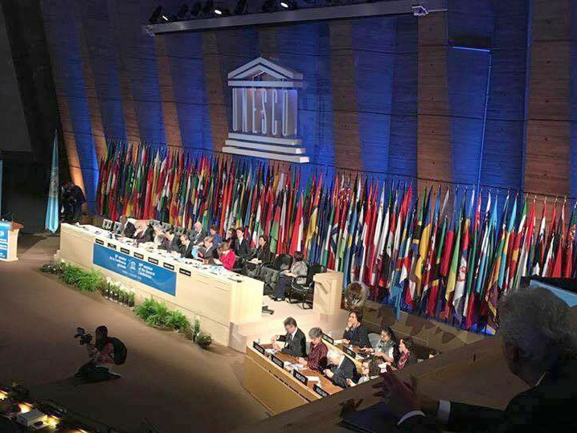

In 2021, UNESCO announced its intention to promote social acceptance of the sustainable development of the Earth's geological resources. "*The University of Hradec Králové employs experienced experts who were familiar with the topic. Together with our team and other scientists and practitioners, we have proposed new ways to bring the beauty and value of the natural and cultural heritage of geoparks closer to common people,*” comments Luboš Gardoň, director of the Barrandian National Geopark.

The project called 4GEON is focused on education and interpretation in geoparks, which in addition to the already mentioned Barrandian, the largest geopark in the Czech Republic, also the Colca and Andagua Volcano Geopark from Peru, Ngorongoro Lengai from Tanzania, Rio Coco from Nicaragua and the Bohol Island Geopark from the Philippines. "*It's also going to be about connecting what locals have known and shared for generations with how people from outside the world perceive it. It was the cultural diversity, the imaginativeness of the project's activities and the inclusion of the four continents that UNESCO evaluators highlighted when they ranked the project among the top three in the world, with a five-year support perspective*, "said Josef Zelenka, professor at University of Hradec Králové.

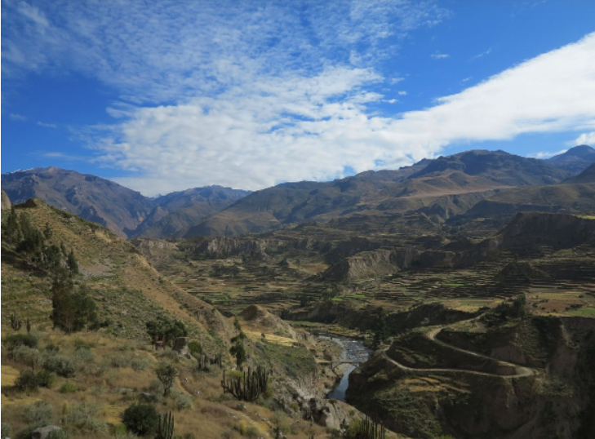

"*The fact that the project is moving in the right direction is proven by the ongoing results of the team's work after the first three weeks. We are preparing a new educational geoweb and cooperation with foreign geoparks is in full swing,* "adds Radek Mikuláš, a world-famous paleontologist in the position of chief researcher at the Geological Institute of the Academy of Sciences of the Czech Republic.